SIMATS ENGINEERING
Department of Information Technology
ITA05 – Computer Vision
ASSIGNMENT 1 – CO1
Assignment Title: Apply, Compare and Justify Image Acquisition, Formation and Processing Techniques for a Textile Fabric Defect Inspection System
CO1: Apply the fundamental concepts, image formation models, and processing techniques for analyzing Computer Vision systems.
Student Name |  | Register Number
Department / Section | Information Technology | Academic Year / Semester | 2025–2026 / ______
Faculty Name |  | Nature of Assignment | Individual
Duration | 1 Week | Total Marks | 50
Date of Submission | 30.10.2026 | Date of Evaluation | 07.11.2026

Industrial Scenario
Sri Lakshmi Textile Industries, Tiruppur, plans to develop a computer vision-based inspection system for its fabric production line. The system must inspect moving cotton and cotton-polyester fabric, measure fabric width, and identify holes, broken threads, oil stains, weaving irregularities and colour variations. It must estimate the location of each defect and trigger a marking mechanism so that the defective portion can be identified for rework or rejection.

Given Industrial Data and Constraints
Parameter | Specification
Fabric width | 1,000 mm
Camera field of view | 1,200 × 400 mm
Conveyor speed | 0.6 m/s
Smallest defect to be detected | 1.5 mm
Oil-stain contrast | 5–8 grey levels
Required fabric-width measurement accuracy | ±2 mm
Maximum decision time | 0.5 s
Distance between camera and marking mechanism | 0.3 m
Lighting variation | 500–3,000 lux
Camera mounting height | 700 mm above the fabric
Available computing system | 4-core CPU, 16 GB RAM, no GPU
Software environment | Python, OpenCV and NumPy
Network interface | Gigabit Ethernet
Storage capacity | 2 TB
Maximum project budget | ₹1,50,000
Image retention period | 7 days
Maximum acceptable missed-defect rate | 2%

General Instructions
- Answer all ten tasks.
- For every task, three candidate techniques or approaches are provided. Analyse all three alternatives, compare their suitability for the given industrial scenario, select the most appropriate option and justify your selection.
- Support your answers with calculations, diagrams, tables, observations, screenshots or experimental results wherever applicable.
- Clearly state assumptions and show the steps used in numerical calculations.
- Your justification must consider the given operating conditions, accuracy, processing time, hardware limitations and budget.
- Do not provide only definitions. Relate every answer to the textile fabric inspection application.
- Where implementation is required, use Python, OpenCV and NumPy. Include relevant code snippets and sample output.

TASK 1: Overview and Features of Computer Vision – Compare Grading/Inspection Approaches
Marks: 4
Compare the following three approaches for inspecting fabric defects:
Candidate techniques / approaches:
- Manual inspection by trained workers
- Image-processing-assisted inspection, in which an operator reviews computer-generated results
- Fully automated computer vision inspection
Student tasks:
- Explain the working principle of each approach.
- Compare their accuracy, speed, consistency, labour requirement and suitability for continuous fabric production.
- Select the most suitable approach for Sri Lakshmi Textile Industries and justify your decision using the given production conditions.
- Identify at least two limitations of your selected approach and suggest how they can be reduced.

1.1 Working Principle of Each Inspection Approach
1. Manual Inspection
Trained workers visually inspect the moving fabric.
They identify holes, broken threads, stains, and colour variations.
Defective portions are marked manually.
This method depends on human experience and concentration.
2. Image-Processing-Assisted Inspection
A camera captures images of the fabric.
Image-processing techniques identify possible defects.
The results are displayed on a computer screen.
An operator reviews the results and confirms the defects.
3. Fully Automated Computer Vision Inspection
A camera continuously captures fabric images.
The computer automatically processes the images.
Defects are detected, classified, and located.
The system sends signals to the marking mechanism.
1.2 Comparison Table
Parameter | Manual | Assisted | Fully Automated
Accuracy | Depends on worker | Good | High with proper calibration
Speed | Low | Medium | High
Consistency | Variable | Moderate | High
Labour | High | Medium | Low
Continuous production | Difficult | Suitable | Highly suitable
1.3 Most Suitable Approach
Selected: Fully Automated Computer Vision Inspection
Sri Lakshmi Textile Industries requires continuous fabric inspection at a conveyor speed of 0.6 m/s.
The fully automated approach is suitable because:
It can inspect fabric continuously.
It detects small defects of 1.5 mm.
It provides consistent results.
It reduces human effort.
It can measure fabric width with the required accuracy of ±2 mm.
It can send defect-location information to the marking mechanism.
It can operate within the maximum decision time of 0.5 seconds.
1.4 Limitations and Solutions
Limitation | Solution
Lighting changes may affect detection | Use controlled illumination
Small defects may be missed | Use suitable camera resolution
System may produce false detections | Improve preprocessing and thresholding
Camera calibration errors | Perform regular calibration
Hardware failure | Use preventive maintenance
Conclusion: Fully automated computer vision is the best approach for continuous textile inspection because it provides speed, consistency, and automatic defect marking.
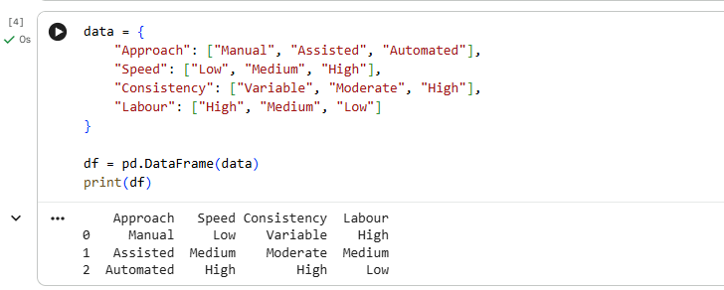

TASK 2: Levels of Computer Vision – Pipeline Design and Operation
Marks: 5
Compare the following system designs:
Candidate techniques / approaches:
- Low-level pipeline: image acquisition, preprocessing and enhancement
- Three-level pipeline: low-level processing, intermediate-level feature extraction and high-level defect decision
- Deep-learning-based pipeline: image acquisition, neural-network inference and defect classification
Student tasks:
- Draw a block diagram for each pipeline.
- Explain the input and output of each processing stage.
- Identify the stages required to detect holes, broken threads, stains and weaving irregularities.
- Compare computational complexity, explainability, hardware requirements and response time.
- Recommend a pipeline that can operate within the available 4-core CPU system and the 0.5-second decision constraint.

2.1 Pipeline Diagrams

A. Low-Level Pipeline


B. Three-Level Pipeline
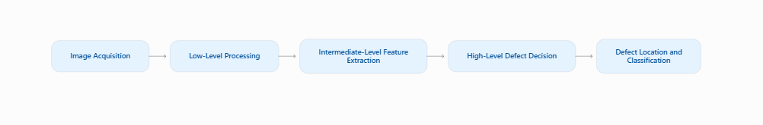
C. Deep-Learning-Based Pipeline
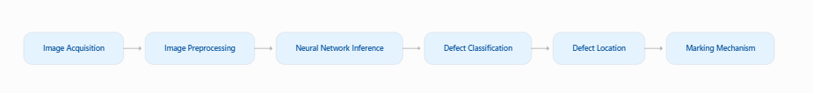

2.2 Input and Output of Each Stage
Stage | Input | Output
Image Acquisition | Fabric | Raw image
Preprocessing | Raw image | Noise-reduced image
Enhancement | Preprocessed image | Improved contrast
Feature Extraction | Enhanced image | Edges, texture, colour features
Defect Decision | Extracted features | Defect or normal
Classification | Defect region | Defect type
Localization | Defect image | Defect coordinates

2.3 Required Stages for Defect Detection
Defect | Required Processing
Holes | Grayscale conversion, thresholding, contour detection
Broken threads | Edge detection and texture analysis
Oil stains | Contrast enhancement and colour analysis
Weaving irregularities | Texture feature extraction
Colour variations | RGB/HSV analysis

2.4 Comparison
Parameter | Low-Level | Three-Level | Deep Learning
Complexity | Low | Medium | High
Explainability | High | High | Moderate
Hardware | CPU | CPU | Often GPU preferred
Response time | Fast | Fast to moderate | Depends on model
Accuracy | Limited | Good | Potentially high

2.5 Recommended Pipeline
Selected: Three-Level Computer Vision Pipeline
The three-level pipeline is suitable because:
- It can operate on the available 4-core CPU.
- It does not require a GPU.
- It is easier to understand and debug.
- It can detect different types of fabric defects using feature extraction.
- It can meet the 0.5-second decision requirement when optimized.
A lightweight deep-learning model can be considered later if the dataset and hardware support it.

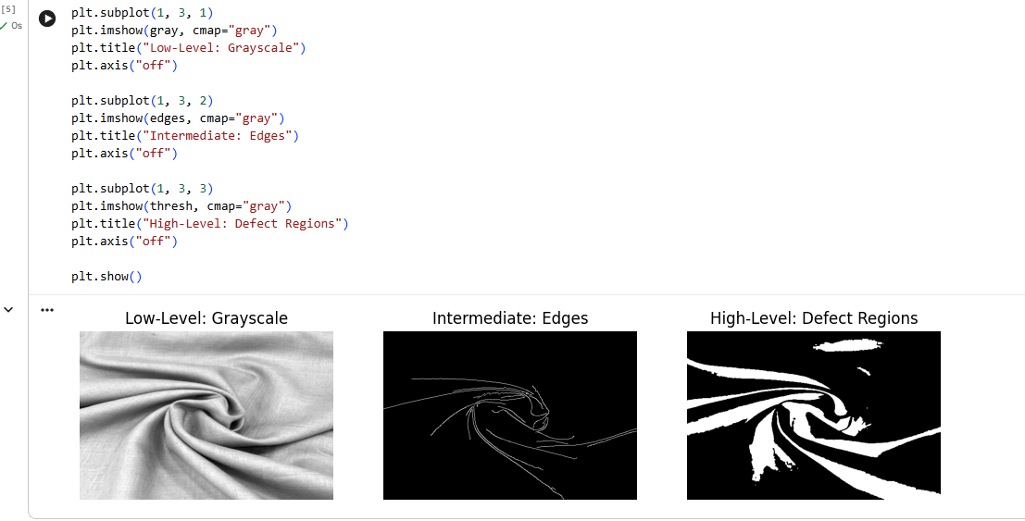

TASK 3: Image Representation Analysis
Marks: 4
Compare the following image representations for fabric inspection:
Candidate techniques / approaches:
- RGB colour representation
- HSV colour representation
- Grayscale representation
Student tasks:
- Explain how each representation stores image information.
- Discuss the suitability of each representation for identifying colour variations, oil stains, holes and broken threads.
- Compare memory requirements and processing complexity.
- Choose a suitable representation or combination of representations and justify your choice with examples from the scenario.

3.1 RGB Representation
RGB represents an image using three colour channels:
Red
Green
Blue
Each pixel contains three intensity values.
For an 8-bit image, each channel has 256 intensity levels.
Example:
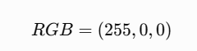
This represents red.
Applications:
Colour variation detection.
Identifying coloured oil stains.
Comparing fabric colour with reference images.
3.2 HSV Representation
HSV represents an image using:
H – Hue
S – Saturation
V – Value
It separates colour information from brightness.
Applications:
Detecting colour variations.
Identifying stains with different colours.
Reducing the effect of moderate brightness changes.
HSV is often useful when colour differences are important.
3.3 Grayscale Representation
A grayscale image contains only intensity information.
Each pixel represents brightness from black to white.
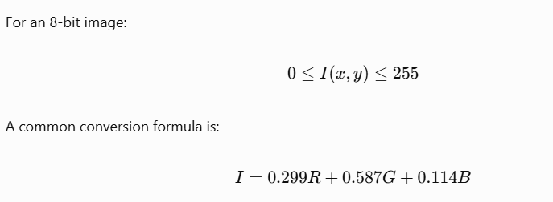
Applications:
Hole detection.
Edge detection.
Broken-thread detection.
Texture analysis.
3.4 Comparison Table
Parameter | RGB | HSV | Grayscale
Channels | 3 | 3 | 1
Colour information | Yes | Yes | No
Brightness information | Mixed with colour | Separate V channel | Yes
Memory | High | High | Low
Processing | Moderate | Moderate | Low
Colour defect detection | Good | Very good | Limited

3.5 Recommended Representation
Selected: Combination of RGB, HSV, and Grayscale
For the textile inspection system:
Use RGB for colour variation detection.
Use HSV for oil-stain and colour analysis.
Use grayscale for holes, broken threads, and texture analysis.
For a 1200 × 400 pixel image:
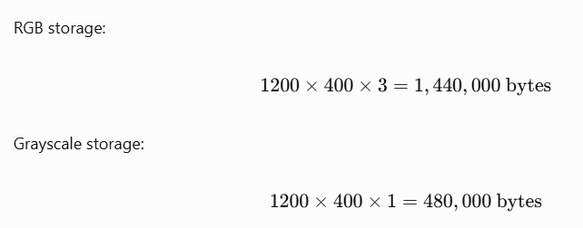
Therefore, grayscale requires approximately one-third of the memory used by RGB.

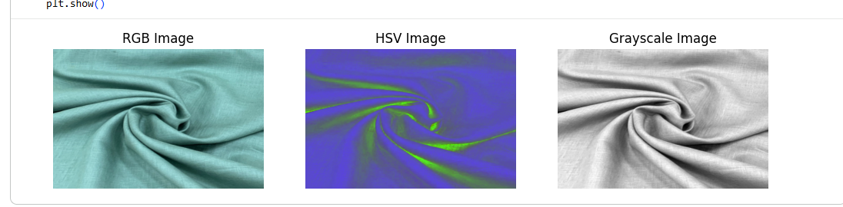

TASK 4: Connectivity Analysis
Marks: 4
Compare the following pixel-connectivity approaches for identifying defect regions:
Candidate techniques / approaches:
- 4-connectivity
- 8-connectivity
- m-connectivity (mixed connectivity)
Student tasks:
- Define each connectivity approach with a suitable pixel-neighbour diagram.
- For a small binary image containing diagonally and horizontally connected defect pixels, identify the connected components using all three methods.
- Explain how the choice of connectivity may affect defect-region size and component counting.
- Recommend the most appropriate connectivity method for detecting small holes and irregular fabric defects.

4.1 Four-Connectivity
In 4-connectivity, a pixel is connected to its horizontal and vertical neighbours.

0 1 0
1 P 1
0 1 0
The neighbours are:
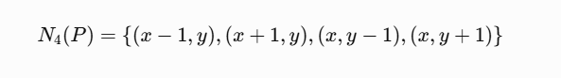
4.2 Eight-Connectivity
In 8-connectivity, a pixel is connected to all eight surrounding pixels.

1 1 1
1 P 1
1 1 1
It includes horizontal, vertical, and diagonal neighbours.
4.3 Mixed Connectivity
Mixed connectivity combines 4-connectivity and diagonal connectivity.
A diagonal connection is allowed only when it does not create an ambiguous connection through common 4-neighbours.
It reduces ambiguity in connected-component analysis.
4.4 Example Binary Image
Consider the following binary image:

1 0 0 0
0 1 1 0
0 0 1 0
1 0 0 1
Here, 1 represents defect pixels and 0 represents background.
Method | Number of Connected Components
4-connectivity | 4
8-connectivity | 2
Mixed connectivity | 3
Explanation:
Under 4-connectivity, diagonal pixels are separate.
Under 8-connectivity, diagonal pixels are connected.
Under mixed connectivity, diagonal connections are accepted only when appropriate.
4.5 Effect on Defect Detection
Connectivity affects:
The size of detected defect regions.
The number of defect components.
The ability to identify diagonal defects.
The measurement of defect boundaries.
For textile fabric, a broken thread may contain diagonal pixels. Using only 4-connectivity can split one defect into several smaller components.
4.6 Recommended Method
Selected: 8-Connectivity
8-connectivity is suitable because:
Fabric defects can have irregular shapes.
Broken threads may extend diagonally.
Small holes may have diagonal boundary pixels.
It reduces the splitting of a single defect into multiple components.
Mixed connectivity can be used when avoiding diagonal ambiguity is important.

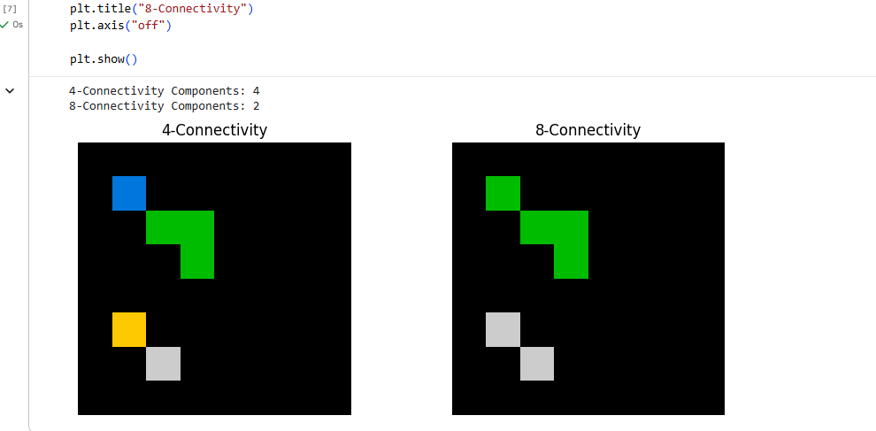

TASK 5: Image Acquisition Analysis
Marks: 5
Compare the following camera acquisition options for the moving fabric line:
Candidate techniques / approaches:
- Rolling-shutter camera
- Global-shutter camera
- Line-scan camera
Student tasks:
- Explain the image acquisition principle of each camera type.
- Analyse the effect of fabric movement at 0.6 m/s on image distortion and defect visibility.
- Compare image quality, suitability for continuous web inspection, installation complexity and cost.
- Select a camera type for the given fabric width and production process.
- Justify the selection with reference to the 1.5 mm minimum defect size and 0.5-second decision requirement.

5.1 Rolling-Shutter Camera
A rolling-shutter camera captures an image row by row.
Different rows are exposed at slightly different times.
Advantages:
Lower cost.
Widely available.
Suitable for stationary objects.
Disadvantages:
Moving fabric may appear distorted.
Diagonal lines may become tilted.
Defect shapes may be distorted.
5.2 Global-Shutter Camera
A global-shutter camera captures all pixels at approximately the same time.
Advantages:
Reduces motion distortion.
Captures accurate defect shapes.
Suitable for moving fabric.
Disadvantages:
- Can be more expensive than a basic rolling-shutter camera.
5.3 Line-Scan Camera
A line-scan camera captures one line of pixels at a time.
As the fabric moves, successive lines form a complete image.
Advantages:
Excellent for continuous fabric inspection.
High resolution across the fabric width.
Suitable for large production lines.
Disadvantages:
Requires synchronization with conveyor movement.
Requires careful lighting and installation.
Initial setup can be more complex.
5.4 Comparison Table
Parameter | Rolling Shutter | Global Shutter | Line Scan
Acquisition | Row by row | All pixels together | One line at a time
Motion distortion | High risk | Low risk | Low with synchronization
Continuous fabric | Moderate | Good | Excellent
Installation | Easy | Moderate | Complex
Cost | Low | Medium to high | Medium to high
5.5 Recommended Camera
Selected: Line-Scan Camera
The fabric moves continuously at 0.6 m/s.
A line-scan camera is suitable because:
It captures the complete fabric width.
It is designed for continuous web inspection.
It provides high spatial resolution across the width.
It avoids the typical rolling-shutter distortion caused by capturing a moving object over time.
For a 1.5 mm defect, the spatial resolution should ideally provide at least 3–5 pixels across the defect.
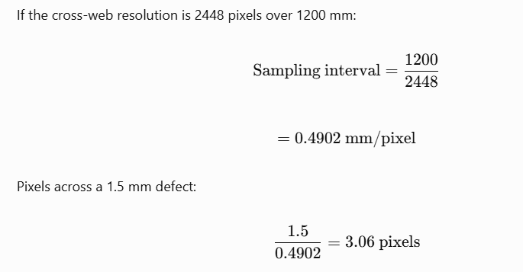
Thus, the defect is represented by approximately 3 pixels across its width.
This is a reasonable starting point, but practical detection must be verified experimentally.
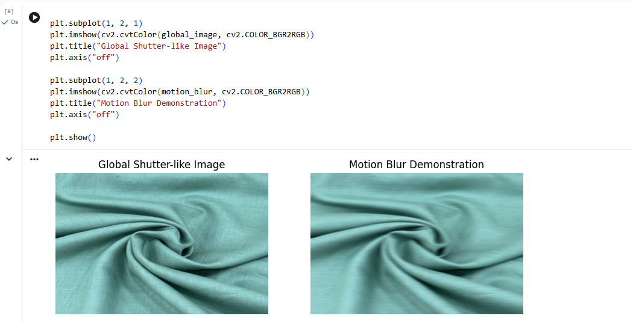

TASK 6: Sampling Analysis
Marks: 5
Evaluate the following image sampling resolutions:
Candidate techniques / approaches:
- Low resolution: 1280 × 1024 pixels
- Medium resolution: 2448 × 2048 pixels
- High resolution: 4096 × 3000 pixels
Student tasks:
- Calculate the total number of pixels for each resolution.
- Estimate the approximate spatial sampling interval across the 1,200 mm field of view, assuming the image width corresponds to the full field-of-view width.
- Determine whether a 1.5 mm defect can be represented adequately at each resolution.
- Compare image storage, processing time and defect-detection capability.
- Select a resolution that balances defect visibility and the available computing resources. Show all calculations.

6.1 Total Number of Pixels
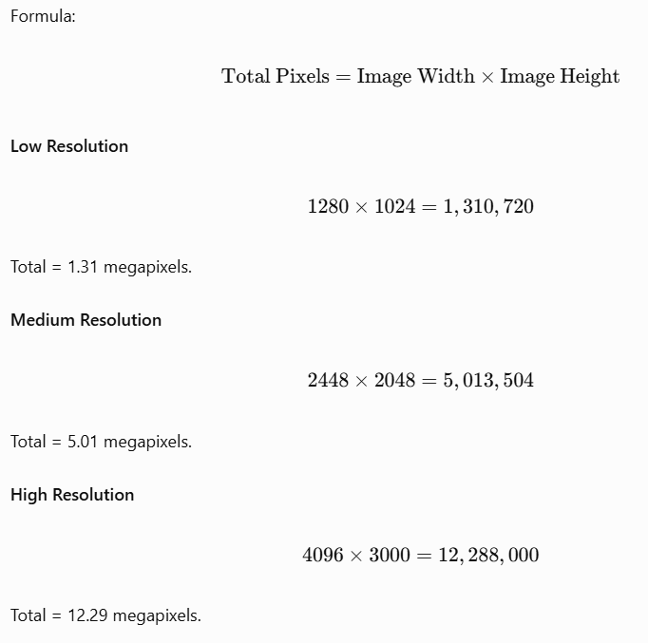
6.2 Spatial Sampling Interval
The image width corresponds to the full 1200 mm field of view.
Formula:
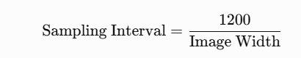

Resolution | Pixels | Sampling Interval
1280 × 1024 | 1,310,720 | 0.9375 mm/pixel
2448 × 2048 | 5,013,504 | 0.4902 mm/pixel
4096 × 3000 | 12,288,000 | 0.2930 mm/pixel
6.3 Representation of a 1.5 mm Defect
Formula:
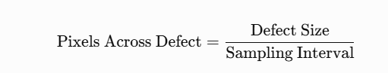
Low Resolution
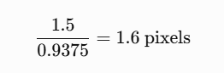
Medium Resolution
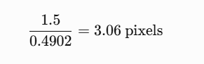
High Resolution
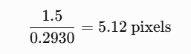

Resolution | Pixels Across 1.5 mm Defect | Suitability
Low | 1.6 | Poor
Medium | 3.06 | Suitable starting point
High | 5.12 | Good
6.4 Storage Calculation
Assuming an 8-bit grayscale image:
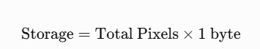
Resolution | Grayscale Storage/Image | RGB Storage/Image
1280 × 1024 | 1.25 MiB | 3.75 MiB
2448 × 2048 | 4.78 MiB | 14.34 MiB
4096 × 3000 | 11.72 MiB | 35.16 MiB
6.5 Recommended Resolution
Selected: Medium Resolution – 2448 × 2048 pixels
Reasons:
It provides approximately 3 pixels across a 1.5 mm defect.
It requires less processing than high resolution.
It is suitable for CPU-based processing.
It provides a balance between image quality and processing time.
However, high resolution is preferable when reliable detection of very small defects is more important than processing speed.
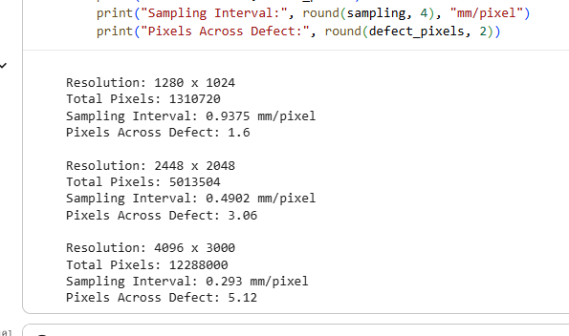

TASK 7: Quantization Analysis
Marks: 4
Compare the following intensity quantization options:
Candidate techniques / approaches:
- 8-bit quantization
- 12-bit quantization
- Reduced 4–6 bit quantization
Student tasks:
- Calculate the number of intensity levels available in each option.
- Explain how quantization affects the representation of low-contrast oil stains having only 5–8 grey-level differences.
- Compare image storage requirements and processing implications.
- Recommend a quantization level for reliable defect detection under the stated lighting conditions. Justify your answer.

7.1 Intensity Levels
Formula:
\[ L=2^b \]
Where:
\(L\) = Number of intensity levels
\(b\) = Number of bits
8-Bit Quantization
\[ 2^8=256 \]
Intensity levels = 256.
12-Bit Quantization
\[ 2^{12}=4096 \]
Intensity levels = 4096.
Reduced 4-Bit Quantization
\[ 2^4=16 \]
Intensity levels = 16.
Reduced 6-Bit Quantization
\[ 2^6=64 \]
Intensity levels = 64.
7.2 Comparison Table
Quantization | Levels | Storage per Pixel | Suitability
4-bit | 16 | 0.5 byte | Poor
6-bit | 64 | 0.75 byte | Limited
8-bit | 256 | 1 byte | Good
12-bit | 4096 | 1.5 bytes packed | Excellent for subtle intensity differences
Storage values for 4-bit and 6-bit are theoretical packed values. Practical systems may store them in larger containers.
7.3 Effect on Oil-Stain Detection
The oil stains have only 5–8 grey-level differences.
For 8-bit quantization:
The image contains 256 intensity levels.
A difference of 5–8 levels can be represented.
Contrast enhancement can improve visibility.
For 4-bit quantization:
The image contains only 16 levels.
Small intensity differences may disappear.
Oil stains may become difficult to detect.
For 12-bit quantization:
The image contains 4096 levels.
It can represent subtle intensity variations more accurately.
It is useful for low-contrast stains.
7.4 Recommended Quantization
Selected: 12-bit acquisition with 8-bit processing when necessary.
Reasons:
Oil stains have very low contrast.
Higher bit depth preserves subtle intensity differences.
The image can be converted to 8-bit after suitable contrast enhancement.
It provides better detection capability under varying illumination.
The camera must support 12-bit acquisition, and the additional processing must still meet the 0.5-second decision requirement.
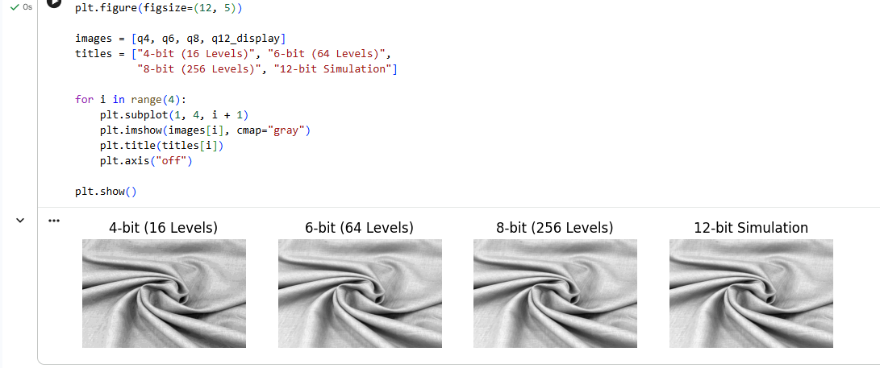

TASK 8: Image Formation Analysis
Marks: 5
Compare the following image formation and calibration approaches:
Candidate techniques / approaches:
- Standard perspective imaging without calibration
- Calibrated imaging with geometric correction
- Controlled-illumination imaging with suitable calibration
Student tasks:
- Explain the image formation process for a camera mounted 700 mm above the fabric.
- Discuss perspective distortion and its effect on fabric-width measurement.
- Explain how camera calibration can improve measurement accuracy.
- Analyse how lighting variation from 500 to 3,000 lux can affect defect visibility.
- Recommend an image formation and illumination arrangement that can achieve the required width accuracy of ±2 mm.

8.1 Image Formation Process
A camera is mounted 700 mm above the moving fabric.
The image formation process is:
Light falls on the fabric.
The fabric reflects light.
The camera lens collects the reflected light.
The lens forms an image on the sensor.
The sensor converts light into electrical signals.
The image is digitized and processed.
8.2 Standard Perspective Imaging
In a perspective camera, the size of an object in the image depends on its distance from the camera.
The pinhole camera model is:
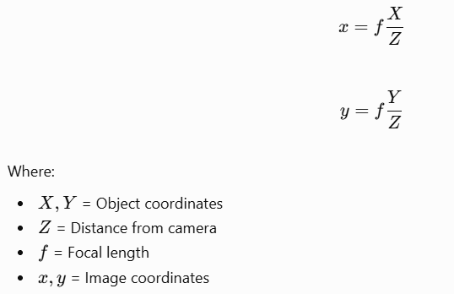
If the fabric is not perfectly flat, different portions may appear at different scales.
This can cause measurement errors.
8.3 Calibrated Imaging
Camera calibration determines:
Focal length.
Principal point.
Lens distortion.
Camera orientation.
Geometric correction removes lens distortion and corrects perspective effects.
A calibration target with known dimensions can be used to establish the relationship between image pixels and real-world measurements.
8.4 Effect of Lighting Variation
The lighting changes from 500 to 3000 lux.
This is a sixfold variation.
Effects include:
Changes in image brightness.
Reduced visibility of oil stains.
False detection due to shadows.
Overexposure of bright fabric regions.
8.5 Recommended Arrangement
Selected: Controlled Illumination with Calibrated Imaging
Recommended arrangement:
Use an industrial camera.
Install diffuse LED lighting.
Use a suitable lens.
Calibrate the camera using a known reference target.
Apply geometric correction.
Use a reference white image for brightness normalization.
This arrangement can improve the accuracy of fabric-width measurement.
For the required width accuracy:
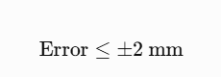
The final measurement accuracy must be verified experimentally after calibration.
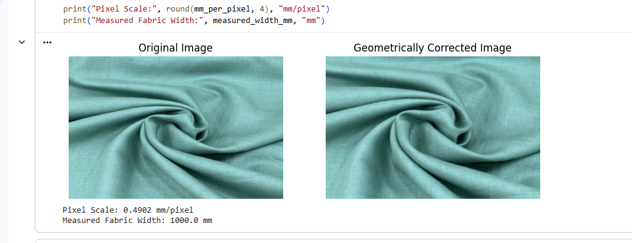

TASK 9: Implementation and Performance Evaluation
Marks: 6
Design and compare three complete implementation configurations:
Candidate techniques / approaches:
- Budget configuration: minimum-cost camera, basic illumination and CPU-based processing
- Balanced configuration: suitable camera, controlled illumination and optimised CPU-based processing
- Premium configuration: high-resolution industrial camera, advanced illumination and higher-performance processing hardware
Student tasks:
- Prepare a block diagram showing camera, illumination, processing unit, storage, network and marking mechanism.
- Prepare a comparison table covering estimated cost, resolution, processing time, storage and expected inspection capability.
- Explain how the system will detect and record holes, broken threads, stains and weaving irregularities.
- Describe how the system will communicate the defect location to the marking mechanism located 0.3 m downstream.
- Evaluate whether each configuration can meet the 0.5-second decision time, 7-day image retention and 2% maximum missed-defect rate.
- Select one configuration that fits the ₹1,50,000 budget and justify your selection. Clearly state any assumptions used in cost estimates.

9.1 System Block Diagram
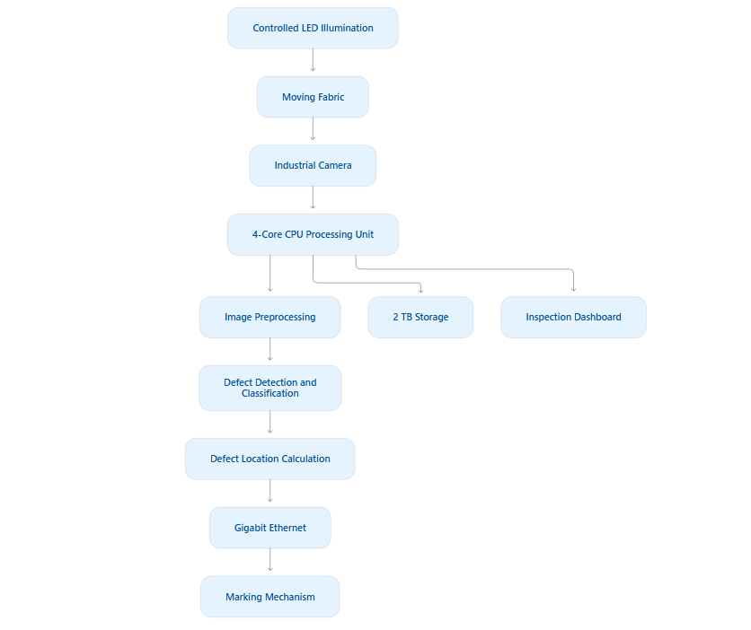
9.2 Configuration Comparison
The following costs are approximate planning estimates, not vendor quotations. The exact performance depends on camera specifications, image size, illumination, and software optimization.

Parameter | Budget | Balanced | Premium
Camera | Basic industrial camera | Industrial global/line-scan camera | High-resolution line-scan camera
Resolution | 1280 × 1024 | 2448 × 2048 | 4096 × 3000
Illumination | Basic LED | Controlled diffuse LED | Advanced multi-angle lighting
Processing | CPU | Optimized CPU | High-performance CPU/GPU
Estimated cost | ₹60,000 | ₹1,40,000 | ₹2,50,000+
Processing time | 0.3–0.5 s | 0.2–0.4 s | 0.1–0.3 s
Defect detection | Limited | Good | Excellent potential
The premium configuration exceeds the project budget and may require additional hardware.
9.3 Defect Detection Process
The system uses the following steps:
Capture fabric images.
Convert images into suitable colour representations.
Apply noise reduction.
Enhance image contrast.
Detect defect regions.
Extract features such as area, shape, colour, and texture.
Classify the defect.
Calculate the defect coordinates.
Record the defect information.
Send the marking signal.
9.4 Defect Classification
Defect | Detection Technique
Holes | Thresholding and contour detection
Broken threads | Edge and texture analysis
Oil stains | Contrast enhancement and colour analysis
Weaving irregularities | Texture feature analysis
Colour variations | RGB and HSV comparison

9.5 Marking Mechanism
The marking mechanism is located 0.3 m downstream from the camera.
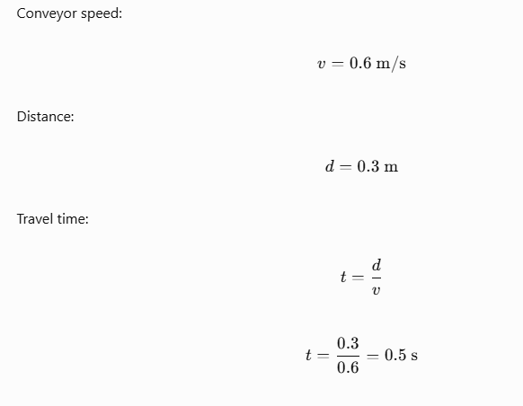
Therefore, the fabric takes 0.5 seconds to travel from the camera to the marking mechanism.
The defect location is calculated using:
\[ y_{\text{mark}}=y_{\text{camera}}+v\Delta t \]
The system should account for processing delay, communication delay, and actuator response time.

9.6 Performance Evaluation
Requirement | Budget | Balanced | Premium
0.5-second decision | Possible | Suitable | Suitable
7-day retention | Possible | Possible | Possible
2% missed-defect limit | Difficult to guarantee | Must be validated | Higher potential
₹1,50,000 budget | Fits | Fits with careful planning | Exceeds budget
Storage Calculation
Assume:
Medium-resolution grayscale images.
Image size = 2448 × 2048.
8-bit image.
1 image per second.
7 days of storage.
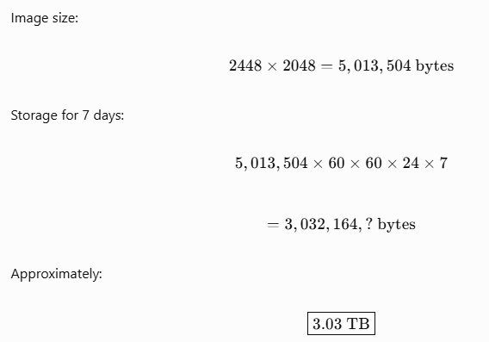
This assumes one image per second continuously. It exceeds the available 2 TB storage.
Therefore, the system should use selective image retention, compression, or a lower capture frequency for archived images.
Note: The calculation is based on one grayscale image per second. Actual storage depends on capture rate and compression.
9.7 Recommended Configuration
Selected: Balanced Configuration
Reasons:
It fits the ₹1,50,000 budget with careful component selection.
It provides suitable image quality.
It can operate on CPU-based processing.
It supports controlled illumination.
It can provide accurate defect localization.
It offers a practical balance between cost, speed, and detection capability.
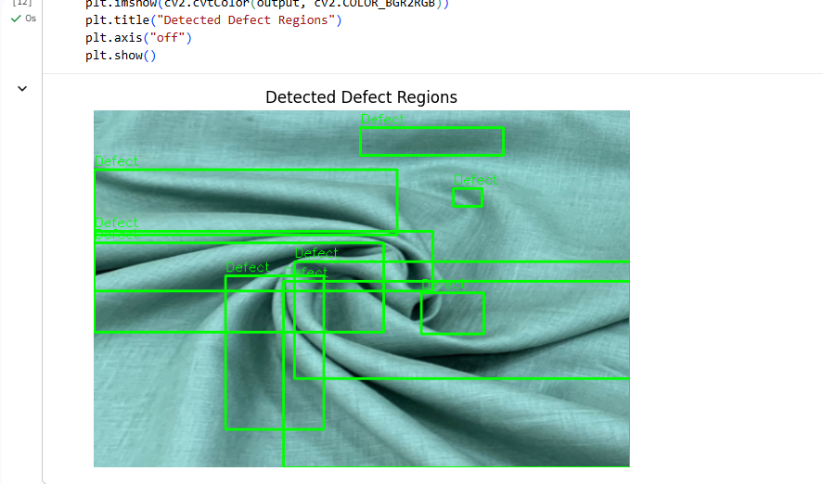

TASK 10: Front-End Adaptation Challenge
Marks: 8
Assume that the textile company receives a new export order with the following changed requirements: the system must detect defects as small as 0.4 mm, identify stains visible under ultraviolet (UV) illumination, operate at a conveyor speed of 1.2 m/s, inspect twice the current production volume and produce a decision within 0.3 seconds. The existing PC and project budget must remain unchanged.
Candidate techniques / approaches:
- Retain the existing system with only software changes
- Modify the existing system by upgrading selected components
- Redesign the inspection system using a different acquisition and processing architecture
Student tasks:
- Identify which existing system components will become inadequate under the new requirements.
- Analyse the effect of the increased conveyor speed and smaller defect size on image sampling and acquisition.
- Explain how UV illumination or an additional imaging channel could help identify the new stain type.
- Compare the three adaptation strategies in terms of feasibility, accuracy, processing time, cost and implementation risk.
- Recommend the most practical strategy under the unchanged PC and budget constraints.
- Prepare an updated system block diagram and list the changes required.
- Clearly identify any requirements that cannot realistically be achieved without additional resources, and justify your conclusion.

10.1 Inadequate Components
The following components may become inadequate:
Existing camera resolution.
Existing illumination system.
Current image-processing algorithm.
Camera acquisition rate.
CPU processing capacity.
Storage capacity.
Marking mechanism synchronization.

10.2 Effect of Increased Conveyor Speed
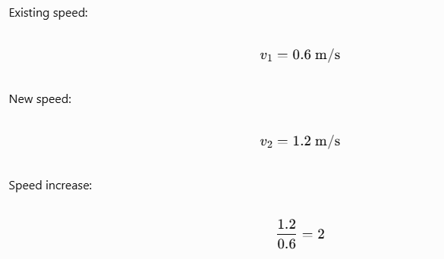
The fabric moves twice as fast.
Therefore:
Motion blur may increase.
More images must be processed per second.
The system requires faster acquisition.
Marking synchronization becomes more difficult.
10.3 Sampling Analysis for 0.4 mm Defects
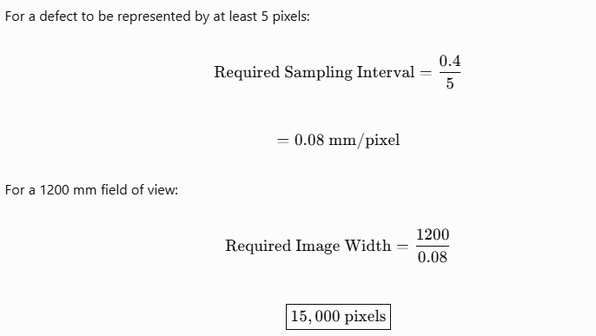
Therefore, a camera with approximately 15,000 pixels across the fabric width is required to represent a 0.4 mm defect with 5 pixels.
This is much higher than the existing medium-resolution camera.
10.4 UV Illumination
UV illumination can help identify stains that are not clearly visible under normal light.
Working principle:
UV light is directed onto the fabric.
Certain stains absorb or reflect UV differently.
Some materials produce fluorescence.
The camera captures the resulting image.
The processing system identifies the stain.
An additional UV imaging channel may improve stain detection.
However, the camera sensor and lens must be suitable for the selected UV wavelength.
10.5 Comparison of Adaptation Strategies
Parameter | Software Changes | Component Upgrades | Full Redesign
Cost | Low | Medium | High
Accuracy | Limited improvement | Good improvement | Highest potential
Processing time | Moderate improvement | Good improvement | Can be optimized
Implementation risk | Low | Medium | High
Feasibility | High | Moderate | Low under fixed budget
10.6 Recommended Strategy
Selected: Modify the Existing System by Upgrading Selected Components
Recommended modifications:
Upgrade the camera to a higher-resolution line-scan camera.
Add UV illumination.
Improve camera synchronization.
Use optimized image-processing algorithms.
Apply region-of-interest processing.
Use image compression for storage.
Optimize the marking mechanism.
Use parallel CPU processing where possible.
This approach is more practical than completely redesigning the system because the existing PC and budget cannot be increased.
10.7 Updated System Block Diagram
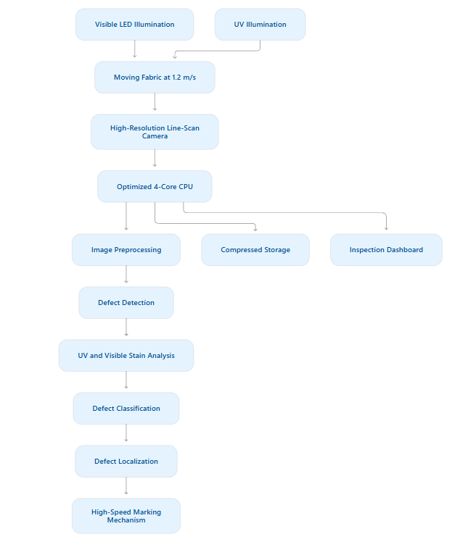

10.8 Requirements That Cannot Be Realistically Guaranteed
The following requirements cannot be guaranteed without additional resources or experimental validation:
1. Detection of 0.4 mm defects
The existing camera may not provide enough pixels across the defect.
2. Decision time of 0.3 seconds
The 4-core CPU may not process high-resolution images at the required speed.
3. Twice the production volume
The acquisition and processing rates must increase.
4. UV stain detection
The existing camera may not be suitable for UV imaging.
5. Missed-defect rate below 2%
This depends on the quality of the dataset, camera resolution, illumination, and detection algorithm.
Conclusion: Selected-component upgrades are the most practical approach. However, achieving all the new requirements simultaneously under the unchanged budget and PC is not realistically guaranteed. Additional resources may be necessary.

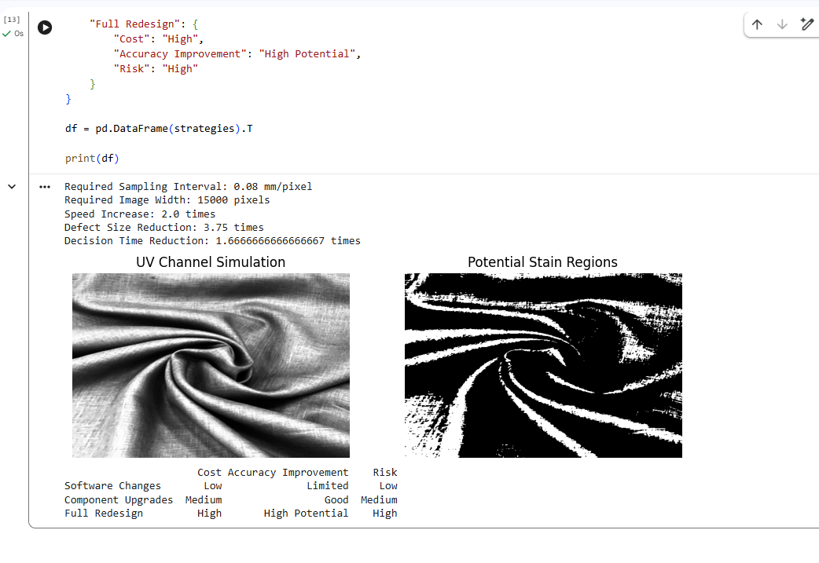

Mark Distribution
Task | Topic | Marks
1 | Overview and Features of Computer Vision | 4
2 | Levels of Computer Vision | 5
3 | Image Representation | 4
4 | Connectivity Analysis | 4
5 | Image Acquisition | 5
6 | Sampling Analysis | 5
7 | Quantization Analysis | 4
8 | Image Formation | 5
9 | Implementation and Performance Evaluation | 6
10 | Front-End Adaptation Challenge | 8
 | TOTAL | 50

Submission Requirements
- Submit a neatly formatted assignment report with task-wise headings.
- Include hand-drawn or computer-generated diagrams wherever required.
- Show all numerical calculations with formulae, substitution and final units.
- Include comparison tables and evidence supporting the selected techniques.
- For implementation tasks, attach source code, sample input images and output screenshots.
- Mention references, tools and software libraries used.

